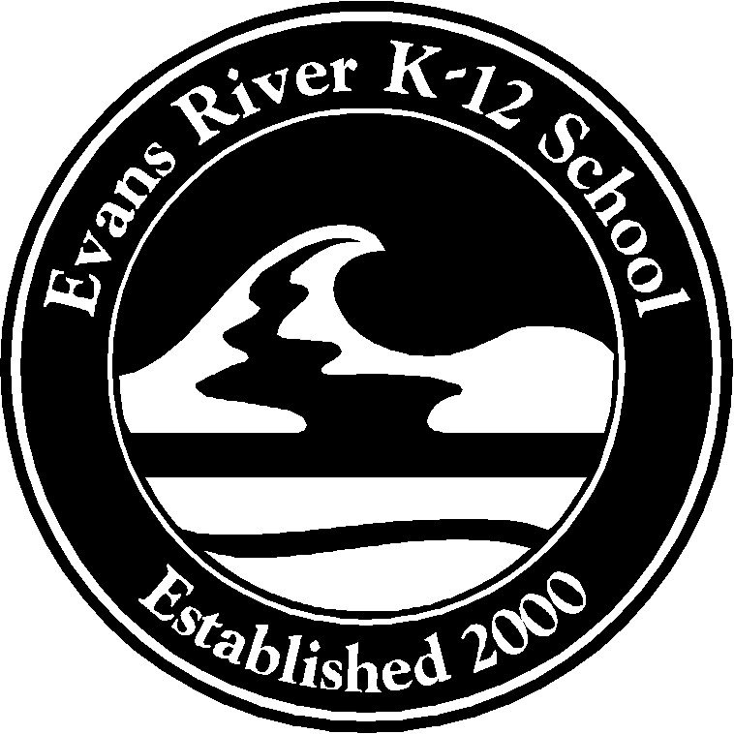
Office/P&C Use Only
Paid
Ready for Collection
Order Collected
On Back Order
Pre-Order
Parents and Citizens Association
Uniform Order Form

Students name
Year
Parent name
Contact number
Date

Summer Uniform
STYLE | PRICE | QNTY | SIZE | TOTAL
*Primary shirt (Years K-6) | 25.00
*Secondary shirt (Years 7-10) | 27.00
Senior shirt (Years 11&12) | 27.00
Sport Shirt- (Years 7-10) | 27.00
Girls Skort with logo (4-14) | 20.00
Boys Shorts (child size 4-14) with logo | 22.00
Boys Shorts (adult XS-XXL) with logo | 22.00
Unisex Shorts (4-14) with logo | 22.00
Unisex Shorts (XS-L) with logo | 22.00
Hats(XS-L) | 10.00

Winter Uniform

STYLE | PRICE | QNTY | SIZE | TOTAL
Zip Front Jumper (with hood) | 35.00
V-Neck Jumper (child size 4-14) | 27.00
V-Neck Jumper (adult S-XXL) | 28.00
Chinooks (child size 4-14) | 27.00
Chinooks (adult XS-L) | 28.00
Chinooks (adult XL-XXL) | 32.00
Waterproof Jacket | 45.00
Waterproof Trackpants | 25.00
 |  |  | TOTAL
 |  |  | AMOUNT PAID
 |  |  | AMOUNT OWING
 |  |  | RECEIPT NUMBER

The uniform store, situated in the Performance Hall will be opened from 8:30am to 9:30am Friday each week
Order forms with payment can be handed into the office.
Eftpos Available.
*Due to stock levels, some shirt sizes will have to be substituted for sport shirts which can be used as everyday shirt

